Fundamentals of Parallel systems

Lab Book

Conner Weatherston (40167111)

Exercise 2-1

Producer

Multiplier

Consumer

Channel 2

Channel 1

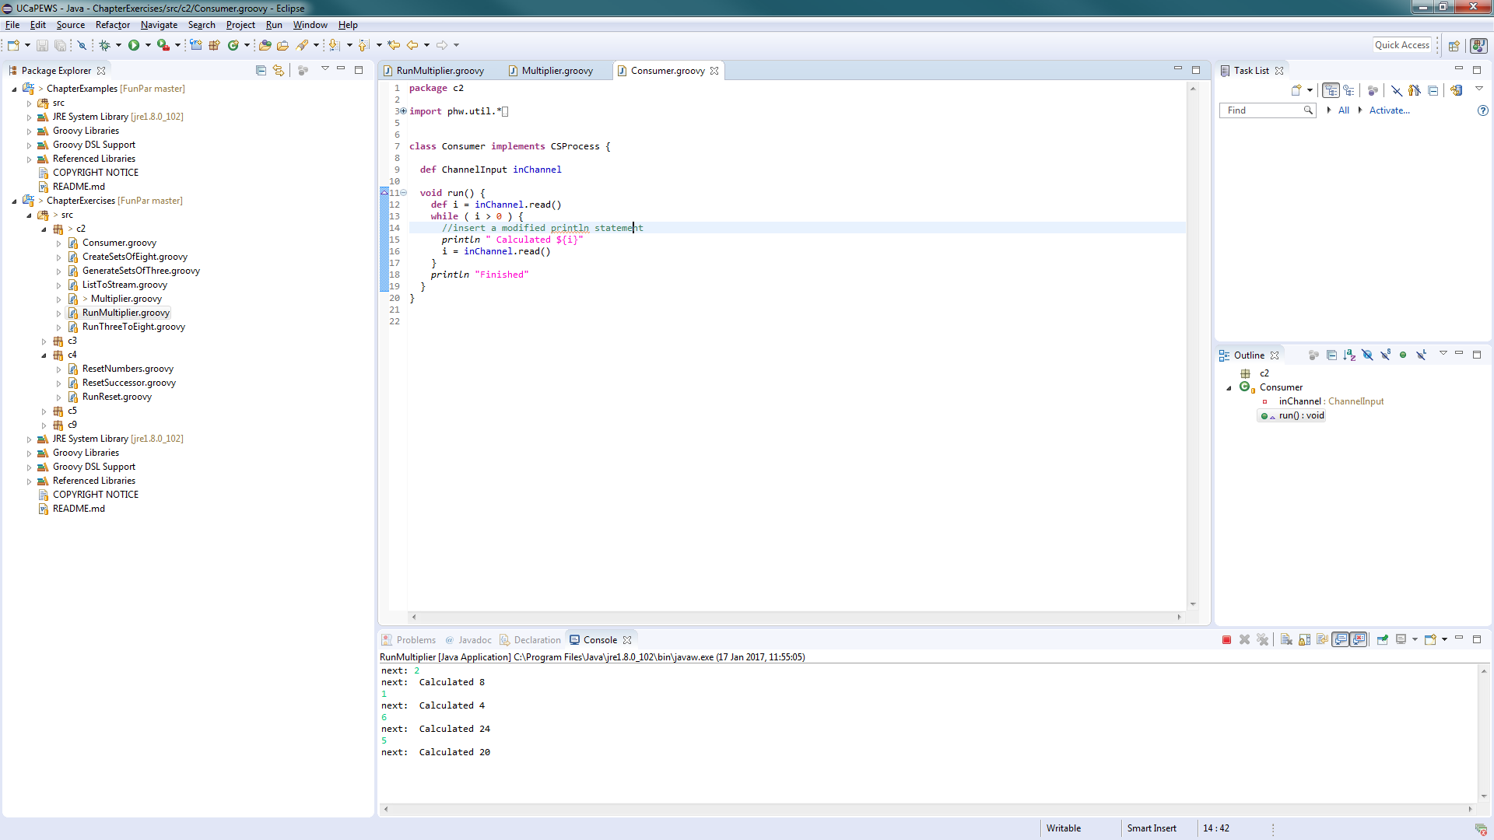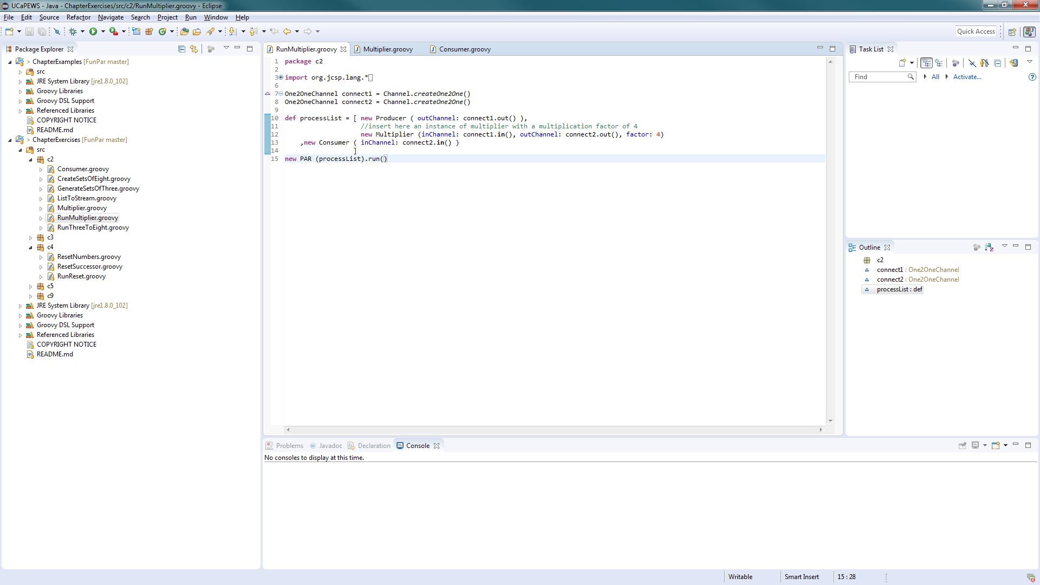

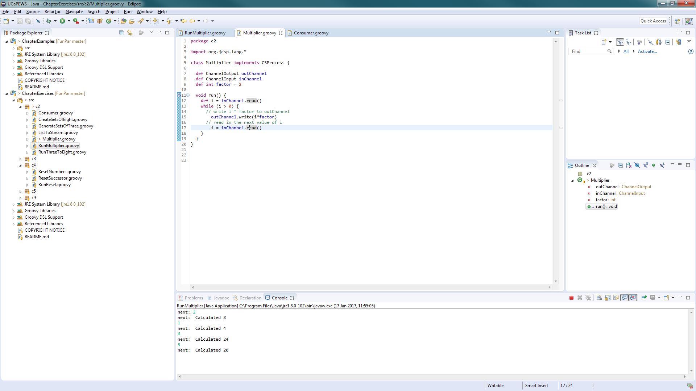

Output

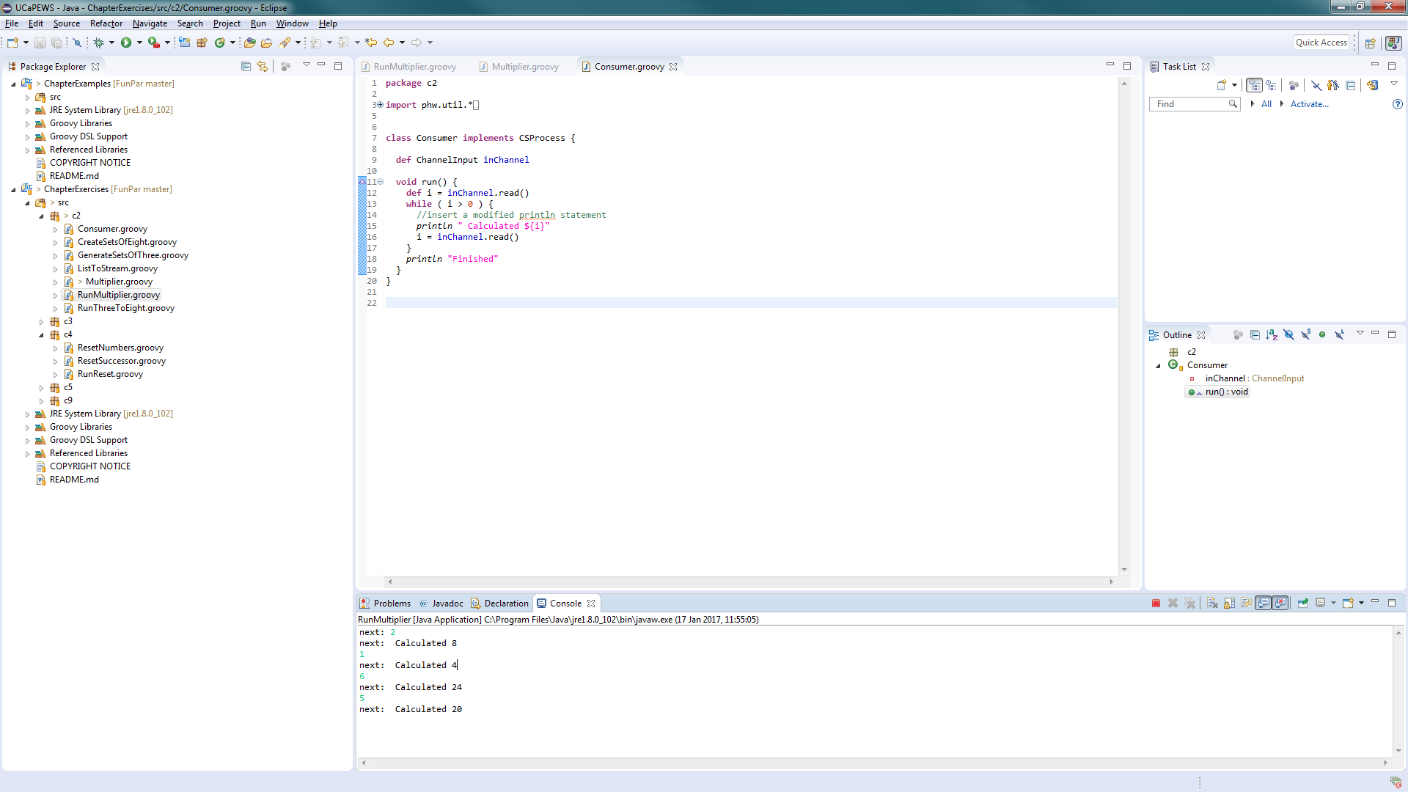

Exercise 2-2

Channel 2

Channel 1

ListToStream

CreateSetsOfN

GenerateSetsOf  
Three

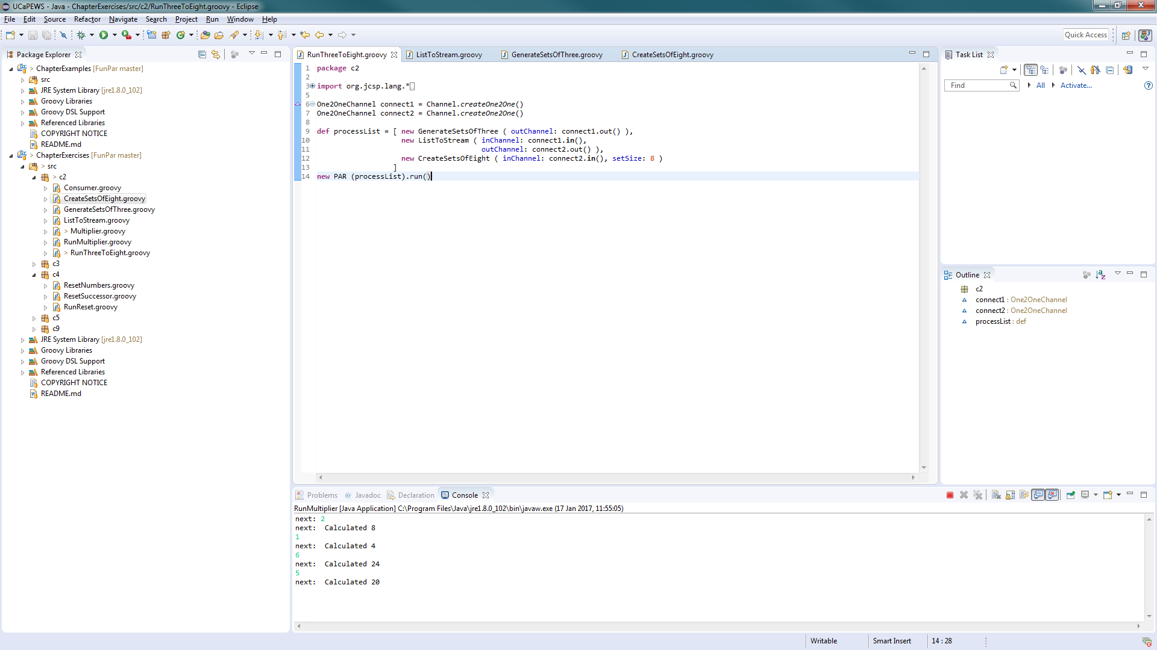

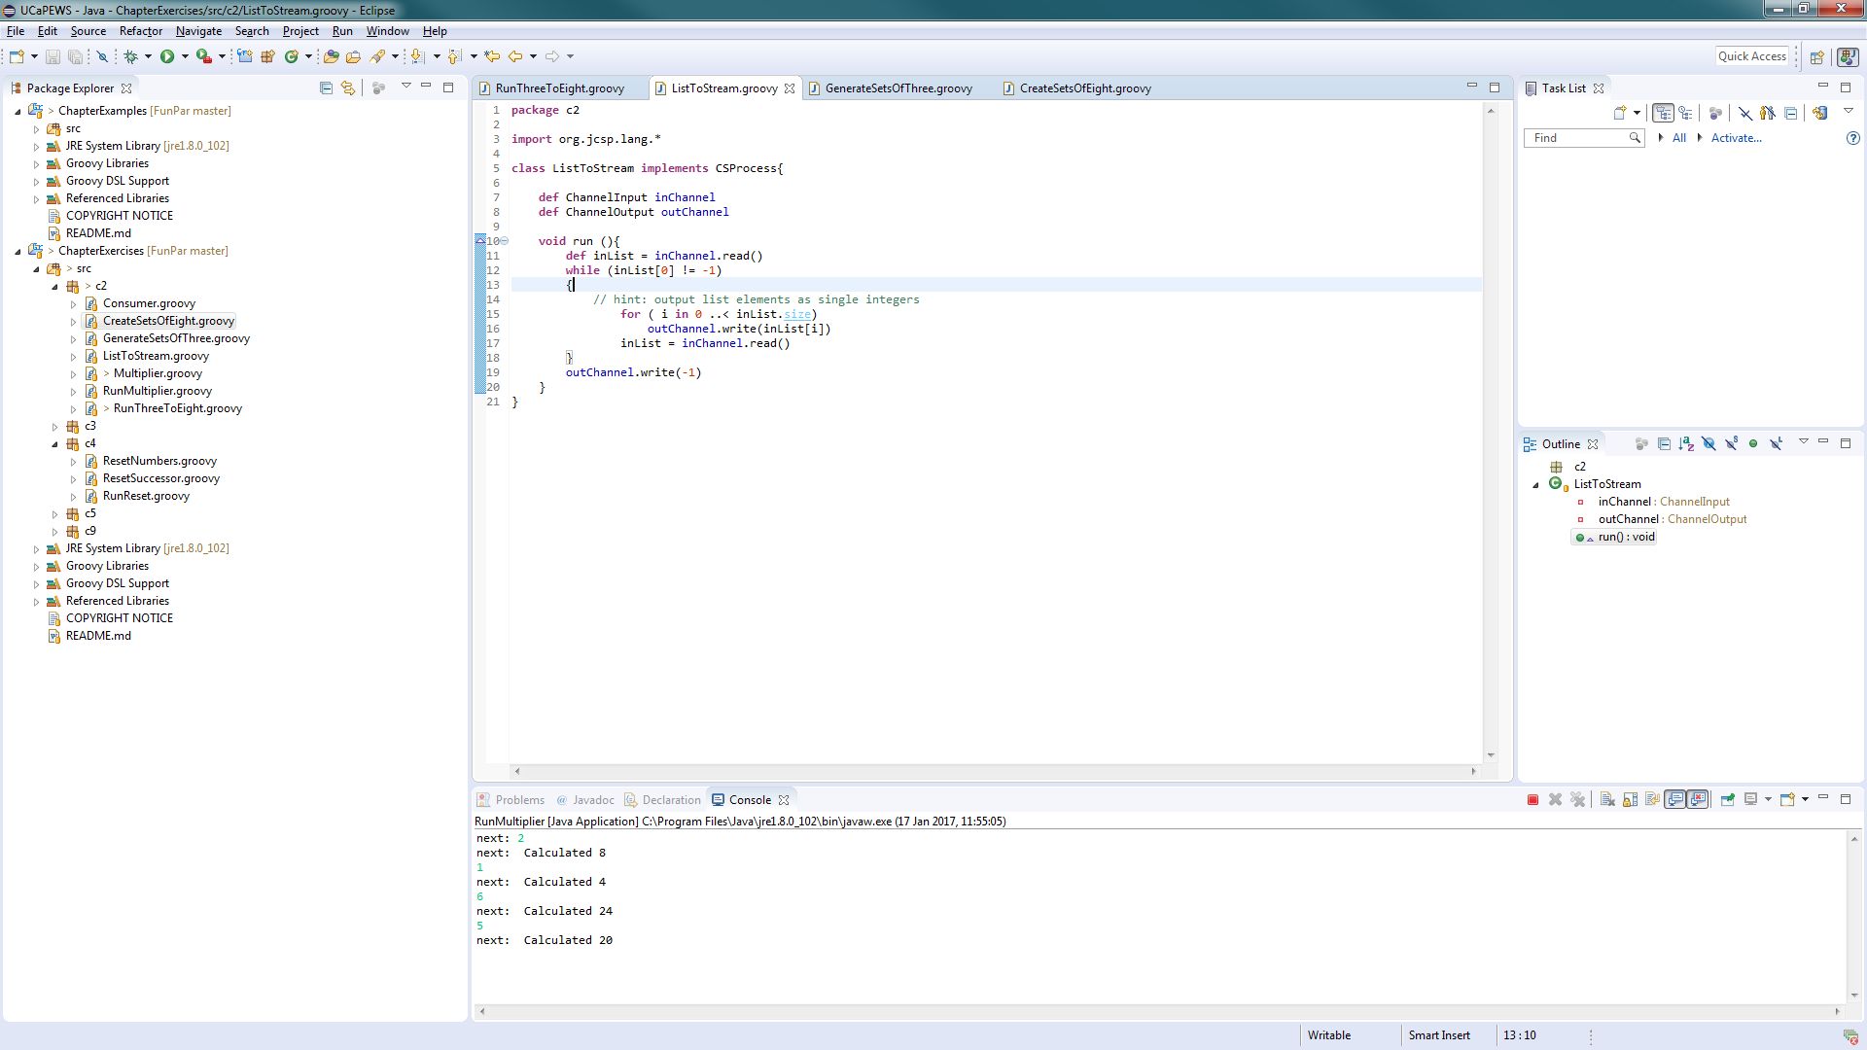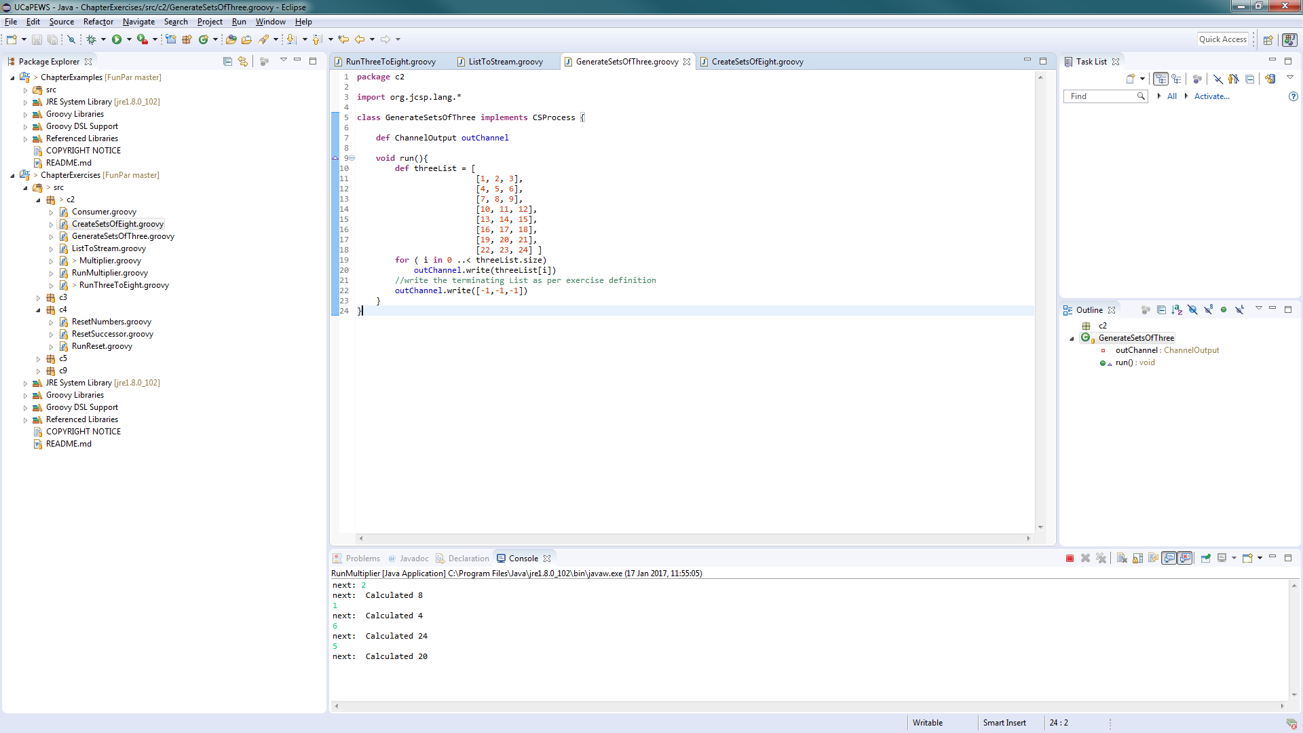

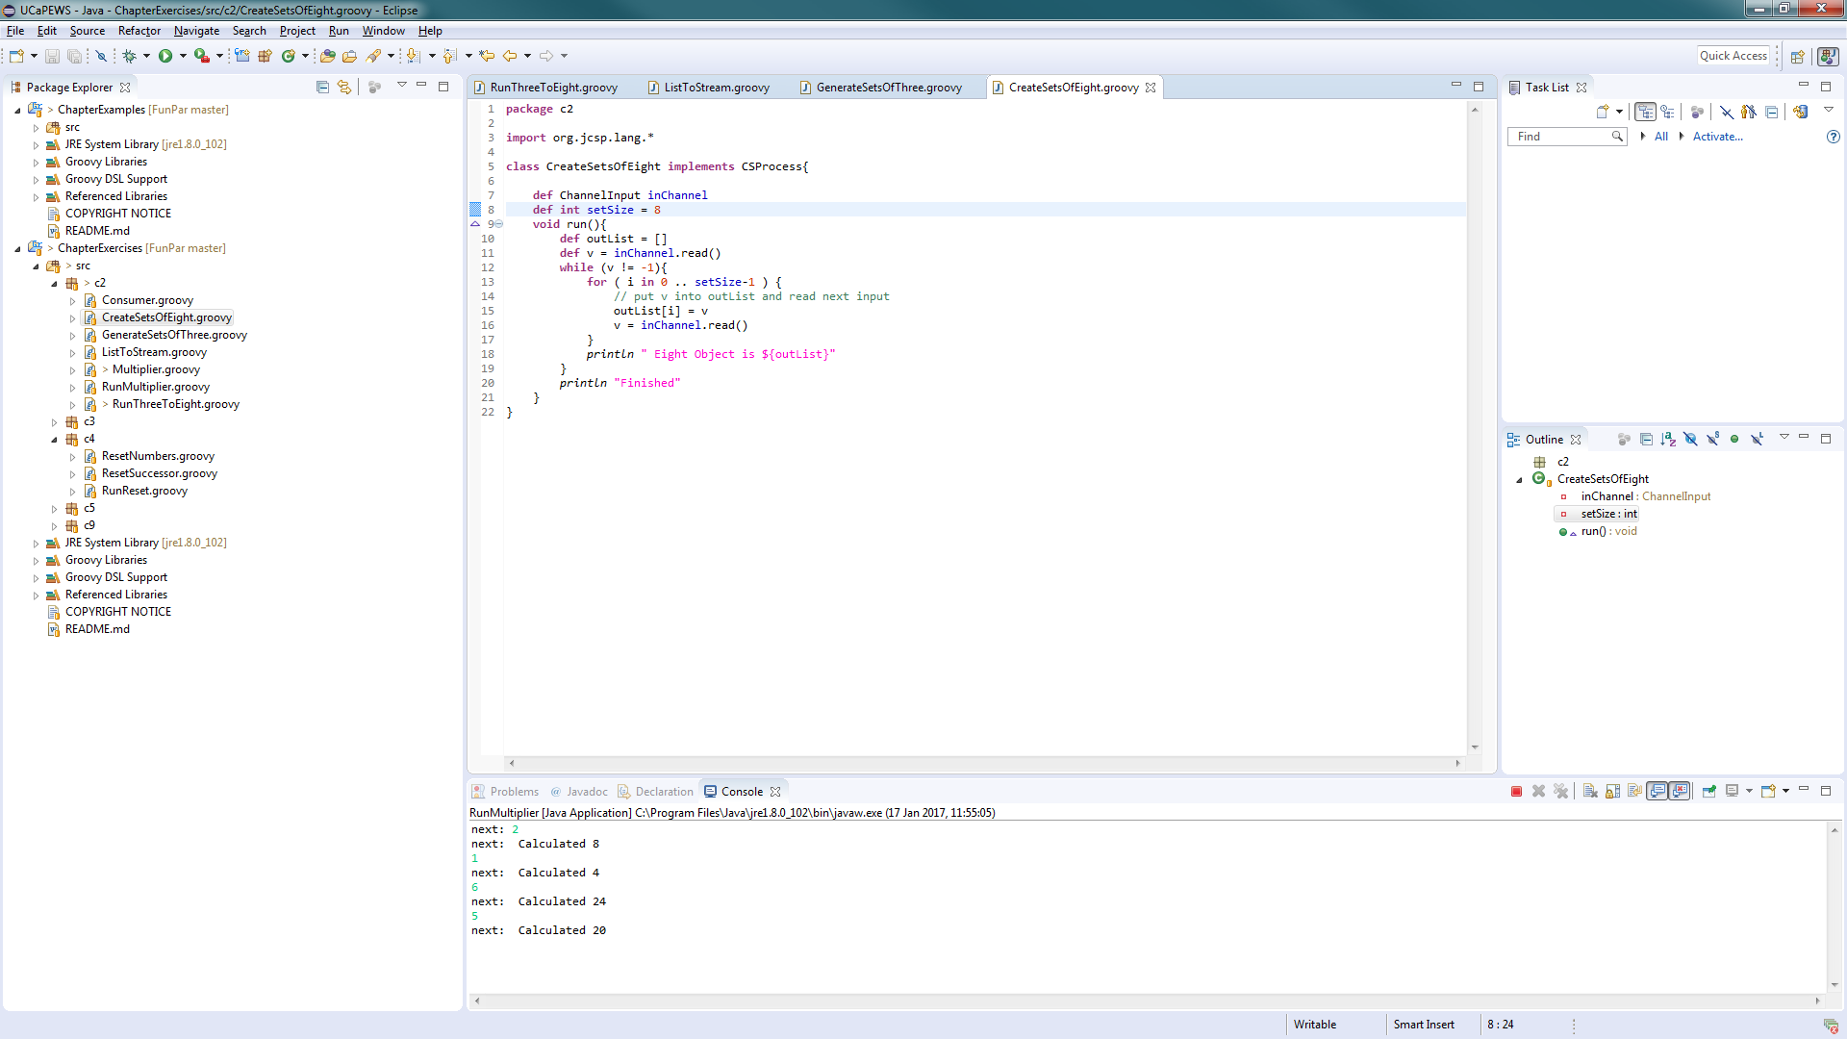

Output.

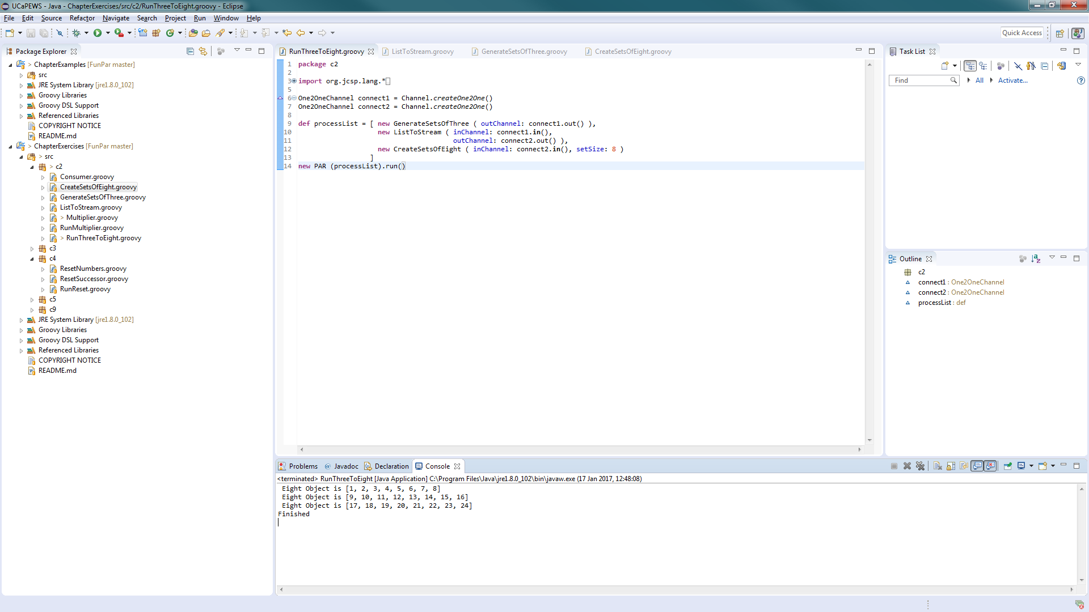

What change is required to output objects containing six integers?

* Change the for loop in the CreateSetsOfN to print out in a list of 6 instead of a list of 8.

How could you parameterise this in the system to output objects than contain any number of integers.

* Create a variable to store what the size of the list is to be outputted.

What happens if the number of integers required in the output stream is not a factor of the total number of integers in the input stream?

* The program omits the remainder of the set that would be printed and cannot terminate.

Exercise 3-1

D2P

I2D

N2I

GPrint

GIntegrate

Differentiate

GNumbers

Differentiate

a

Minus

In

Out

b

c

GPrefix

GPCopy

DifferentiateNeg

a

d

In

GPlus

Negator

GPrefix

GPCopy

out

c

b

The original differentiate approach is better as it provides a more sensible solution to the problem.

Exercise 3-2

GSPairsA

C

B

A

GTail

GPlus

GSCopy

Output

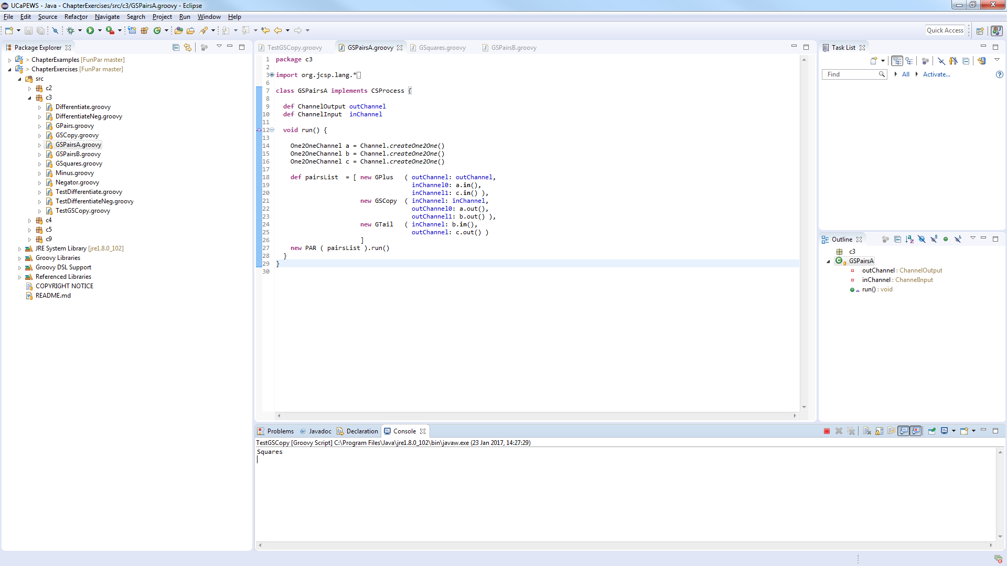

GSPairsB

C

C

B

GTail

GPlus

GSCopy

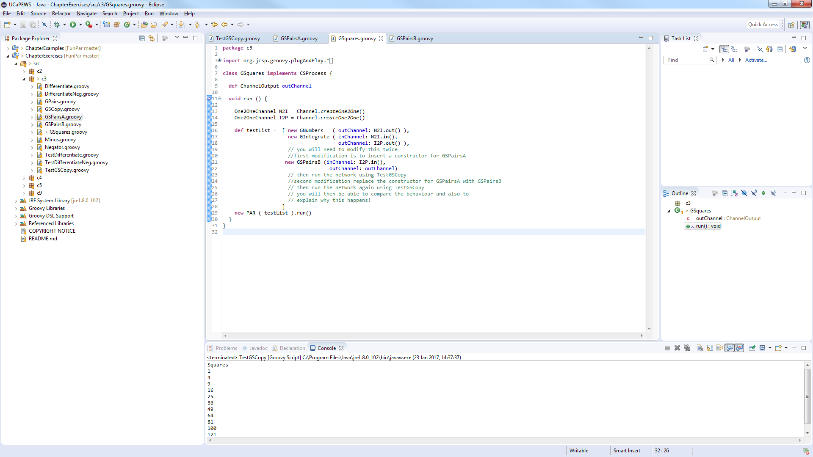Output snippet

The results will keep going.

GSPairsA does not work as the process GPlus will keep asking for another value from the C channel. This input cannot be provided as C needs an value outputted from GTail. This process also cannot get a result as GSCopy cannot execute as there is still a value on the A Channel which cannot be read, thus the entire system fails.

GSPairsB can run as the order of the channels being written too sequentially is correct. As it writes to A first then goes into GTail. After that the value is put onto channel B which GPlus will then ask ask for a value from the C channel. Once this happens the next value from GSCopy can then be put onto the a channel, as it is outputting sequentially and not in parallel. This value will go through the GTail process and then will allow the GPlus process to execute. Once it is executed then GSCopy can output onto channel B and the cycle continues.